## VISVESVARAYA TECHNOLOGICAL UNIVERSITY

**“Jnana Sangama”, Belagavi - 590 018 Karnataka India**



**MINI PROJECT [18ECP68]**

**REPORT ON**

**“NEW BLYNK IOT SMART PLANT MONITORING SYSTEM”**

*Submitted in partial fulfillment of the requirements for the award of the Degree*

##### **BACHELOR OF ENGINEERING**

in

##### **ELECTRONICS AND COMMUNICATION ENGINEERING**

by

**Yashavantha P USN: 1BC20EC002**

**Anand USN: 1BC21EC400**

*Under the Guidance of*

**Mrs. KARTHIKA V**

**Dept. of ECE**

## BCET

**DEPARTMENT OF ELECTRONICS AND COMMUNICATION ENGINEERING**

## BANGALORE COLLEGE OF ENGINEERING & TECHNOLOGY

##### **BANGALORE COLLEGE OF ENGINEERING TECHNOLOGY**

**Opp, Heelalige Railway Station, Chandapura Hosur Main Road, Bengaluru-560099**

# **BANGALORE COLLEGE OF ENGINEERING & TECHNOLOGY**

**Chandapura, Bengaluru - 560099**



**Department of Electronics & Communication Engineering**

***DECLARATION***

We, **YASHAVANTHA P**, bearing USN:1BC20EC002, **ANAND,** bearing USN:1BC21EC400, hereby declare that, the project work entitled “**NEW BLYNK IOT SMART PLANT MONITORING SYSTEM**” is independently carried out by us at Department of Electronics and Communication Engineering, **Bangalore College of Engineering & Technology, Bengaluru-560099**,under the guidance of **Mrs. KARTHIKA V,** Assistant Professor, Department of Electronics and Communication Engineering, Bangalore College of Engineering & Technology. The Project work is carried out in partial fulfillment of the requirement for the award of degree of Bachelor of Engineering in Electronics and Communication Engineering during the academic year 2022- 2023.

**Place: Bengaluru Name & Signature of students**

**Date:**

**BANGALORE COLLEGE OF ENGINEERING & TECHNOLOGY**

**Chandapura, Bengaluru – 560099**



**Department of Electronics & Communication Engineering**

***Certificate***

Certified that the project work entitled “**NEW BLYNK IOT SMART PLANT MONITORING SYSTEM**”, carried out by, **YASHAVANTHA P**, bearing USN:1BC20EC002, **ANAND,** bearing USN: 1BC21EC400 bonafide students of **Bangalore College of Engineering & Technology**, in partial fulfillment for the award of Bachelor of Engineering in Electronics and Communication Engineering of the Visvesvaraya Technological University, Belagavi during the year 2022–2023. It is certified that all the corrections/suggestions indicated for Internal Assessment have been incorporated in the Report deposited in the departmental library. The project report has been approved as it satisfies the academic requirements.

**_______________ _______________ _________________**

**Signature of the guide Signature of the HOD Signature of the Principal**

**Mrs. Karthika V Dr. John Clement Sunder A Dr. Channankaiah**

**Department of ECE Professor and Head Principal**

**BCET, Bangalore BCET, Bangalore BCET, Bangalore**

***External Viva***

**Name of the Examiners Signature with Date**

**1.________________**

**2.________________**

**2._________________**

**ACKNOWLEDGEMENT**

## The satisfaction and euphoria that accompanies the successful completion of any task would be incomplete without the mention of the people who made it possible.

## First of all, we would like to thank Dr. Channankaiah, Principal, Bangalore College of Engineering & Technology, for permitting to do this project work and providing the facilities required.

## We would like to express our sincere thanks to Dr. John Clement Sundar A, Professor and HOD, Department of Electronics and Communication Engineering, Bangalore College of Engineering & Technology for his support. We pay out profound gratefulness and express our deepest gratitude to our project guide Mrs. Karthika V , Assistant Professor, Department of ECE for his suggestions, guidance.

## It is our pleasure to acknowledge the cooperation extended by teaching staff and non-teaching staff members of Department of Electronics and Communication Engineering, Bangalore College of Engineering & Technology for the encouragement during this project work. Finally, it gives immense pleasure to acknowledge the cooperation extended by family members, friends for the encouragement during this project work.

**Name: YASHAVANTHA P[1BC20EC002]**

**Name: ANAND [1BC21EC400]**

**ABSTRACT**

## Plant monitoring is seen as one of the most important tasks in any farming or agriculture based environment. This paper automates plant monitoring and smart gardening using IoT in the NodeMCU system platform. The main purpose of this paper is to provide comfort to the farmer by reducing the manual work by improving the overall performance of the system without the user’s direct interaction. The important parameters for the quality and productivity of plant growth are soil and air temperature, humidity, sunlight and soil moisture. The plant health and growth information has to be provided to the user continuously by monitoring and recording these garden parameters. All the sensors used in this project are interfaced with the NodeMCU. And this information about the plant can be directly monitored and controlled by the farmer through their smart phone using IoT. This smart gardening system will provide convenience and comfort to the user by sensing and controlling the parameters of the plants without their physical presence. Any android supported device can be used to install the smart gardening application. The softwares used are Arduino IDE & Blynk IoT platform. Ardunio IDE is used for compling and uploading the programe to NodeMCU and Blynk IoT platform is used for displaying of temperature, humidity, atmospheric pressure & soil moisture and can be accessed from any distance. This will help the farmer to understand the relation between the plant growth and mentioned plant parameters.

**CONTENTS**

|  |  |  |
| --- | --- | --- |
| **SL.NO** | **INDEX** | **PAGE NO** |
| **1** | **Introduction** | **7** |
| **2** | **Literature Survey** | **9** |
| **3** | **Block Diagram** | **11** |
| **4** | **Circuit Diagram** | **13** |
| **5** | **Components** | **23** |
| **6** | **Methedology** | **24** |
| **7** | **Program Code** | **26** |
| **8** | **Advantages** | **32** |
| **9** | **Disadvatages** | **33** |
| **10** | **Conclusion** | **34** |
| **11** | **Reference** | **36** |

**CHAPTER 1**

**INTRODUCTION**

## Plant plays a vital role in maintaining the ecological cycle and forms the foundation of a food chain pyramid and thus to maintain the plant’s proper growth and health adequate monitoring is required. Hence the aim at making plant monitoring system smart is using automation and Internet of Things (IOT) technology. This topic highlights various features such as smart decision making based on soil moisture real time data.

## The computerized water system framework with IOT is practically and financially sufficient for planning water resources for plantation (group of a plant). Adopting the automatic water system framework we can demonstrate that the utilization of water can be decreased for various plantations (group of plants) usages. The system framework has an appropriated microwaves (wireless) chain of moisture content in the soil through soil moisture sensor, humidity and temperature sensor set in the root zone of the plants and level of water (ultrasonic) sensor is set in tank for checking the water level in tank. The data will gather from the sensors and send to the web server (cloud).

## The background of chapter highlights the study of IOT in the field of agriculture. This shows how we can implement the IOT technology to make our planting smart and reliable with the real time updated data. This chapter also helps the beginners to implement the IOT technology and learn the basics of this technology.

## Internet of Things (IoT) plays an important role in most of the fields. The use of IoT increased because of the various advantages we can get from that. The agriculture is the area where a lot of improvement is needed because that is one of the essential needs and a large sector of people is involved in that. Most of the area the major problem is the water scarcity because of low rainfall and even though there is rainfall the water is wasted because of no proper arrangement for the storage of water. Many techniques are proposed in IoT in terms of providing a better irrigation to the crop. The IoT devices can also be used in home for monitoring the garden real time.

## The Raspberry and Ardunio plays an important role in processing the information that is received from various sensors. The cost of these devices will be affordable and the major issue is the usage of large amount of sensors and other devices. Much research focus is on finding the effect of these devices in the environment, if it causes any side effects to the humans. The Rapberrypi is used wherever a large amount of processing is required and Ardunio in terms of interconnecting certain hardware devices and performs a little amount of processing. The installation of the sensors for finding the humidity level is one major factor to avoid the wastage of water.

**Existing System**

## The existing IoT monitoring systems lack a user-friendly and customizable interface, limiting their usability and effectiveness in various applications. Therefore, the need arises to develop a new Blynk IoT smart monitoring system that addresses these limitations and provides an intuitive platform for users to monitor and control their IoT devices efficiently.

**Proposed System**

## The proposed Plant Monitoring System uses NodeMCU as microcontroller. NodeMCU comes with the inbuilt ESP8266 WiFi module which connects our system to blynk app using WiFi. The program which controls the functioning of the whole system is fed into the microcontroller using Arduino IDE which is an environment which integrates code with the hardware. Soil moisture sensor continuously detects the level of moisture in the soil and displays it on the Virtual LCD widget on the Blynk app. If the water content in the soil is less than what is required by the plant, a notification is sent to the user smartphone and he/she can switch ON the button widget in Blynk app which will turn ON the water supply. Real time values from the DHT11 temperature sensor are also displayed on the virtual LCD. The user is notified about each and every step through the notification feature of the Blynk app. Hence, this system monitors and controls the plants requirements remotely.

## CHAPTER 2

## LITERATURE SURVEY

## Smartphone irrigation sensor

To be used in crops, an automatic irrigation sensor was devised and built. The sensor captures and processes digital pictures of the soil around the crop's root zone with a smartphone and calculates the water content visually. The sensor is housed in a room with regulated lighting and buried at the plant's root level. The smartphone's processing and connection components, such as the digital camera and the Wi-Fi network, were controlled directly by an Android App. The smartphone is activated by the mobile App, which wakes it up according to user-defined settings. Through an anti-reflective glass window, the built-in camera takes a picture of the soil and an RGB to a gray procedure is used to estimate the ratio between the image's moist and dry areas. After established a Wi-Fi connection, the ratio is sent to a gateway for control of an irrigation water pump through a router node.

## Predicting the extent of wildfires using remotely sensed soil moisture and temperature trends

## Predicting the extent of wildfires using remotely sensed soil moisture and temperature trends Weather patterns changes reveal an increase in temperatures, as well as a growth in the duration and frequency of drought, resulting in more severe wildfires, which endangers both the environment and human life. [2] Improved wildfire prediction technologies are critical in this setting. This research explored the significance of remotely sensed soil moisture data as a crucial variable in the climate wildfires association. This research focuses on fires that occurred in the Iberian Peninsula between 2010 and 2014.When investigating their prior-to occurrence surface moisture temperature conditions, researcher utilized SMOS-derived soil moisture data and ERA-Interim land surface temperature reanalysis.

1. **Wireless sensor network based automated irrigation and crop field monitoring system**

## Sensors that can be used wirelessly for agricultural purposes. In order to reduce water usage, a network based automated watering system is utilized. [3] In the agricultural field, a wireless sensor network comprising soil moisture and temperature sensors is used in the system. To handle sensor data, the Zigbee protocol was utilized, and an algorithm using sensor threshold values was used to regulate the water amount programmed on a microcontroller for irrigation. For data examination, a solar panel powers the gadget, which also has a cellular internet interface. Using image processing techniques, to monitor the disease area, a wireless camera is installed in the agricultural field. The technology is low-cost and energy-independent, making it ideal for water-scarce and geographically isolated locations.

## 4.“Project Haritha” - an automated irrigation system for home gardens

## In an urban setting, even the upkeep of a tiny garden may become tiresome. The need of the hour is for a completely automated system that maximizes the utilization of energy and water resources. As a consequence, a multi-mode, extremely energy efficient control for an automated irrigation system has been developed was designed and implemented.T o irrigate a targeted region, the system employs an in-situ soil moisture [4]potential sensor and programmed data. The soil moisture content is monitored using a microcontroller-based data collection and dissemination system. During a system failure, an embedded GSM module gives vital information to the user. The recommended microcontroller-based system was written and tested to see how well it performed.

## Automated irrigation system using a wireless sensor network and GPRS module

## To improve water utilization for crops, an automated irrigation system was created. [5] The system consists of a distributed wireless network of soil moisture and temperature sensors in the root zone of plants. A gateway device also manages sensor data, triggers actuators, and delivers information to a web application. To manage water amount an algorithm containing temperature and soil moisture threshold values was created and implemented into a gateway based on microcontroller panels for photovoltaics.

**6. The Design and Research on Intelligent Fertigation System**

## Crop fertilization is uneven, resulting in either too much or too little fertilization, and the concentration cannot be effectively regulated, which is a serious but typical problem. [6] Accordingly, an intelligent fertilization device has been developed that can automatically water and fertilize, as well as inject and combine fertilizer. Three control algorithms are presented in the paper: fertilizer application control algorithm; fertilizer injection and mixing; and a system priority algorithm. It also describes the system structure and the design of the piping system. This system has a good quality for EC and pH adjustment, a steady performance, and is highly practical, according to the testing findings.

### 

.

## 

**CHAPTER 3**

**BLOCK DIAGRAM**

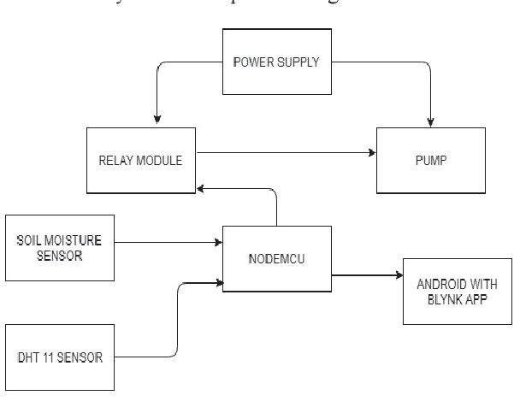

**Fig 3.1**

## 

## 

## Plant Sensors: These are the physical sensors that measure various parameters of the plants, such as soil moisture, temperature, humidity, light intensity, and nutrient levels. These sensors are connected to a microcontroller or an IoT-enabled device.

**Microcontroller/IoT Device:** This component acts as the central processing unit of the system. It receives the sensor data and communicates with the Blynk cloud platform. It may include a microcontroller board like Arduino, ESP8266, or a dedicated IoT device with built-in connectivity options like Wi-Fi or cellular.

**Connectivity:** This block represents the connection between the microcontroller or IoT device and the Blynk cloud platform. It can be a Wi-Fi module, cellular module, or Ethernet module, depending on the available network infrastructure.

**Blynk Cloud Platform:** Blynk is an IoT platform that provides a cloud-based infrastructure for data storage, processing, and visualization. It allows you to create a customizable mobile or web application interface to interact with your IoT devices. The Blynk cloud receives the sensor data and facilitates communication between the user interface and the microcontroller/IoT device.

**Mobile/Web Application:** This block represents the user interface for interacting with the smart plant monitoring system. Blynk provides a drag-and-drop interface builder that allows you to design a custom application for monitoring and controlling your plants. The application can display real-time sensor data, send notifications, and enable remote control of connected devices.

**User:** This is the end user of the system who interacts with the mobile or web application. They can monitor the sensor data, receive alerts, adjust settings, and remotely control devices like irrigation systems or lighting.

**Actuators:** These components enable the user to control various aspects of the plant environment. For example, based on the sensor data and user commands, actuators like pumps, valves, or relays can be activated to water the plants, adjust lighting conditions, or provide nutrients.

The flow of information in this system starts with the plant sensors, which measure the environmental parameters. The microcontroller/IoT device collects this data and establishes a connection with the Blynk cloud platform through a network connection. The Blynk cloud processes the data, stores it, and provides access to the user interface. The user can access the mobile or web application to monitor the sensor readings, receive notifications, and control the actuators to maintain an optimal plant environment.

Overall, the block diagram illustrates the key components and their interactions in Blynk based IoT smart plant monitoring system, enabling users to remotely monitor and

manage their plants' conditions for efficient plant care.

**CHAPTER 4**

**CIRCUIT DIAGRAM**

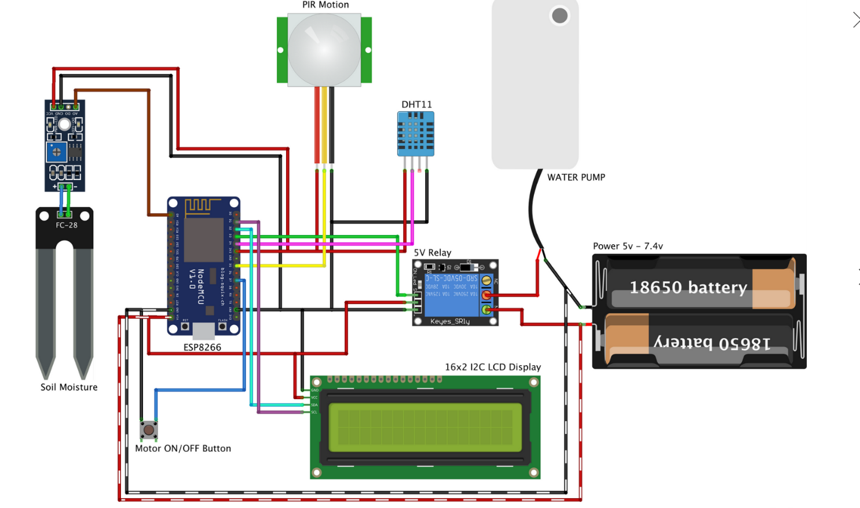

**Fig 4.1**

**NodeMCU ESP8266:**

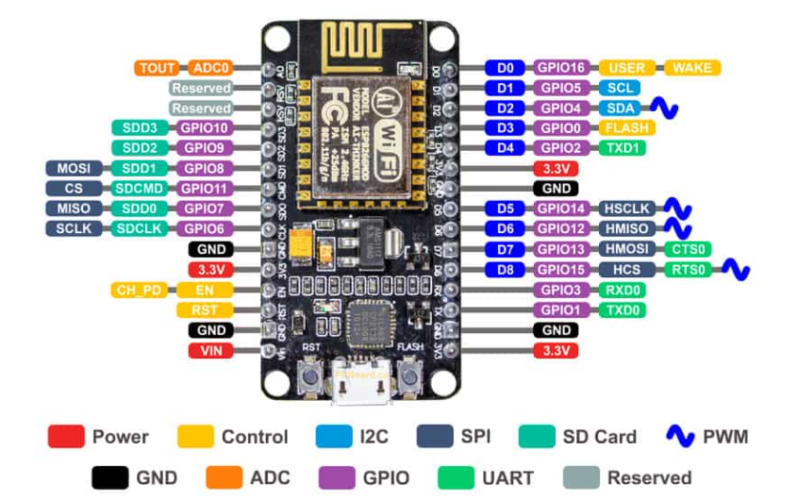

**Fig 4.2**

The ESP8266 NodeMCU CH340 board has ESP8266 which is a highly integrated chip designed for the needs of a new connected world. It offers a complete and self-contained Wi-Fi networking solution, allowing it to either host the application or to offload all Wi-Fi networking functions from another application processor.

ESP8266 has powerful on-board processing and storage capabilities that allow it to be integrated with the sensors and other application-specific devices through its GPIOs with minimal development up-front and minimal loading during runtime. Its high degree of on-chip integration allows for minimal external circuitry, and the entire solution, including the front-end module, is designed to occupy minimal PCB area.

The ESP-12 Lua NodeMCU WIFI Dev Board Internet Of Things with ESP8266 is an all-in-one microcontroller + WiFi platform that is very easy to use to create projects with WiFi and IoT (Internet of Things) applications.

**Features :**

* 11 b/g/n Wi-Fi Direct (P2P), soft-AP.

* Integrated TCP/IP protocol stack.
* Use CH340G to replace the CP2102.
* Integrated low power 32-bit CPU.
* Open-source, Interactive, Programmable, Low cost, Simple, Smart, WI-FI enabled For Arduino-like hardware IO.
* Easy access to the GPIO pins for easy prototyping.
* Easy to use breadboard friendly form factor.
* Voltage Regulator / Converter, excellent DC to DC conversion, super-efficient.

**Soil Moisture Meter:**

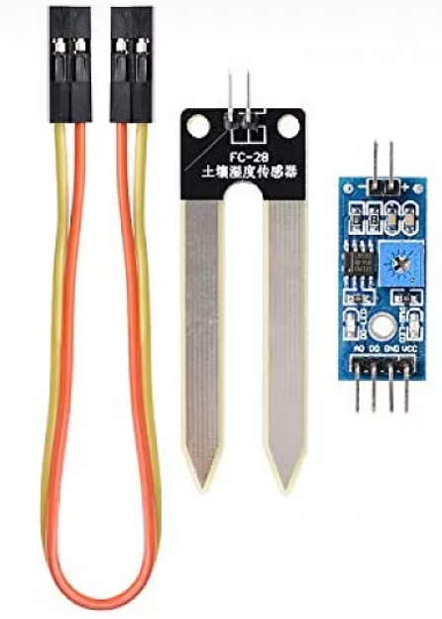

**Fig 4.3**

This is a simple water sensor that can be used to detect soil moisture when the soil moisture deficit module plant waterer device, so that the plants in your garden without people to manage. It gives a digital output of 5V when the moisture level is high and 0V when the moisture level is low in the soil.

**Connection:**

VCC ➠ 3.3V-5V

GND ➠ GND

DO ➠ Digital output interface(0 and 1)

AO ➠ Analog output interface

**Feature:**

* Having LM393 comparator chip, stable.
* Module Output is a high level when the soil moisture deficit or output is low. Can be used in module plant waterer device, and the plants in your garden no need people to manage.
* Adjustable sensitivity by adjusting the digital potentiometer.
* A fixed bolt hole for easy installation.
* With power indicator (red) and digital switching output indicator (green).
* Dual output mode, analog output more accurate.

**PIR Motion Detector Sensor Module:**

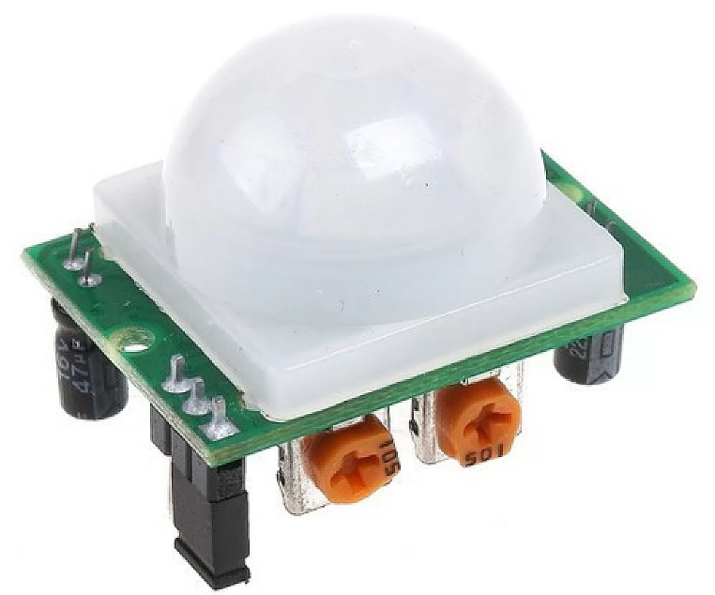

**Fig 4.4**

The HC-SR501 PIR Motion Detector Sensor Module is a pyroelectric device that detects motion by measuring changes in the infrared levels emitted by surrounding objects. This motion can be detected by checking for a high signal on a single I/O pin.

The module has an onboard pyroelectric sensor, conditioning circuitry, and a dome-shaped Fresnel lens. It has a delay time adjustment Potentiometer and sensitivity adjustment Potentiometer.

It is used to sense the movement of people, animals, or other objects. They are commonly used in burglar alarms and automatically-activated lighting systems. Compatible with ARDUINO, RASPBERRY PI, AVR, PIC, 8051, etc.

**Features:**

* Compact size.
* Infrared sensor: dual-element, low noise, high sensitivity.
* Blockade time: 2.5s (Default).
* Infrared Sensor with Control Circuit Board.
* The Sensitivity and Holding Time Can be Adjusted.
* Sensitive Setting: Turn to Right, Distance Increases (About 7M); Turn to Left, Distance Reduce (About 3M).
* Time Setting: Turn to Right, Time Increases (About 200S); Turn to Left, Time Reduce (About 5S).

## 5V Single Channel RELAY Module:

This is a 5V single Channel Relay Board Module For Arduino PIC AVR DSP ARM. A wide range of microcontrollers such as Arduino, AVR, PIC, ARM, and so on can control it. The module is triggered, high trigger current less than 5mA, part of the 51 single-chip IO port output capability is weak, pull or increase the drive capability of the circuit. it Can be used for microcontroller development board module or home appliance control.

**Features :**

* + Trigger mode: Low level.

## One normally closed contact and one normally open contact.

## High impedance controller pin.

## 

## Fig 4.5

* Standard TTL Level logic controlled (AVR, Arduino, 8051, PIC, ARM).
* The module is compliant with international safety standards, control, and load areas isolation trenches.
* Power supply indicator lamp.
* Control indicator lamp.
* Operating Voltage 5V.

**Breadboard:**

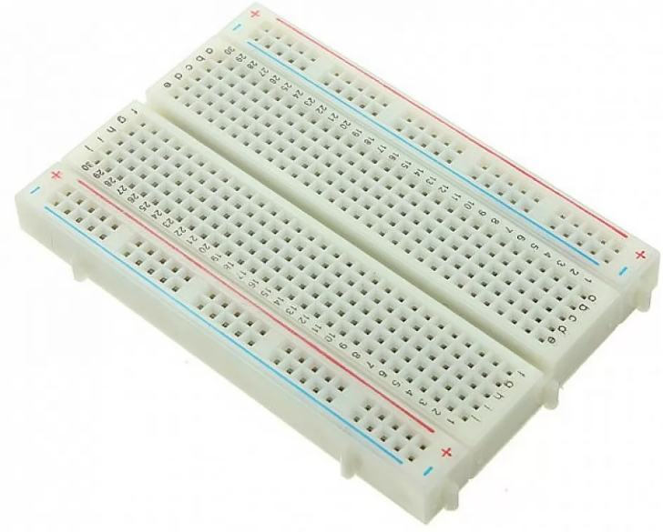

## Fig 4.6

400 Tie Point Solderless Breadboard is a cute half size breadboard, good for small projects. It has 2 power buses, 30 columns, and 10 rows - a total of 400 tie in points. All pins are spaced by a standard 0.1". The two sets of five rows are separated by about 0.3", perfect for straddling a DIP package over. The board accepts wire sizes in the range of 29-20AWG. This board also has a self-adhesive on the back. The boards also have interlocking parts.

**Feature :**

* Type: Plug-in breadboard.
* Size: 3.3 x 0.3 inches.
* Total 400 tie points.
* 2 power buses.
* 400 tie in points.
* 0.1" space.
* 10 rows.
* 3.29 x 2.15 x 0.33" (83.5 x 54.5 x 8.5mm).

**Jumper Cables:**

**Features**

* This is 10pcs of each (total 30 pcs) jumper cable Dupont wire for Arduino.
* High quality and in good working condition.
* Durable and reusable.
* Easy to install and use.
* A popular choice for construction or repair.
* Be used for the electronic project and Genuine Arduino product.

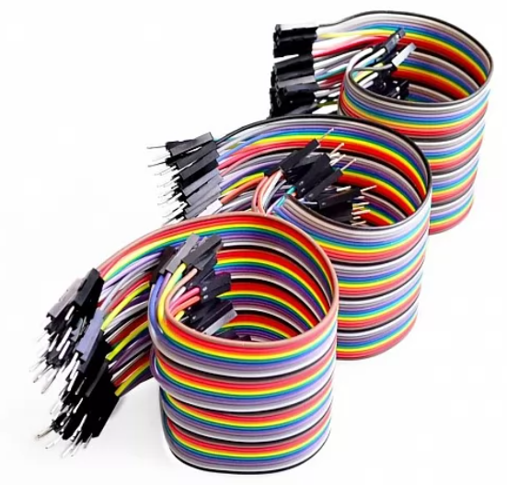

**Fig 4.7**

**DHT11 Sensor:**

**Fig4.8**

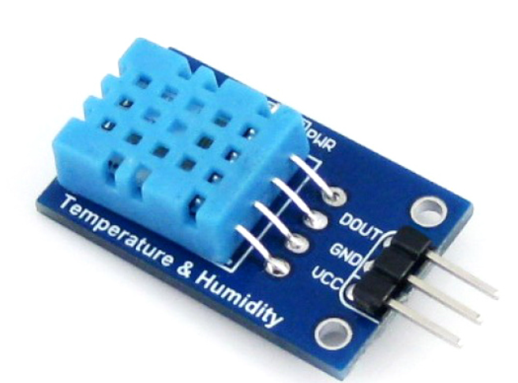

## 

## The DHT11 Temperature And Humidity Sensor Module with LED is a small humidity and temperature sensor that you can connect to your Arduino and get readings for temperature and humidity in the environment. DHT11 can be interface with any microcontroller like Arduino, Raspberry Pi, etc., and get instantaneous results. DHT11 is a low-cost humidity and temperature sensor which provides high reliability and long term stability.

**Features:**

* DHT11 sensor with PCB and LED indicator along with cable; 3 to 5V power and I/O, 4 pins with 0.1″ spacing.
* Good for 20-80% humidity readings with 5% accuracy.

* 2.5mA max current use during conversion (while requesting data).
* Good for 0-50°C temperature readings ±2°C accuracy.
* The board has a pre-built 4.7K or 10K resistor, which you will need to use as a pull-up from the data pin to VCC.

**LCD Display:**

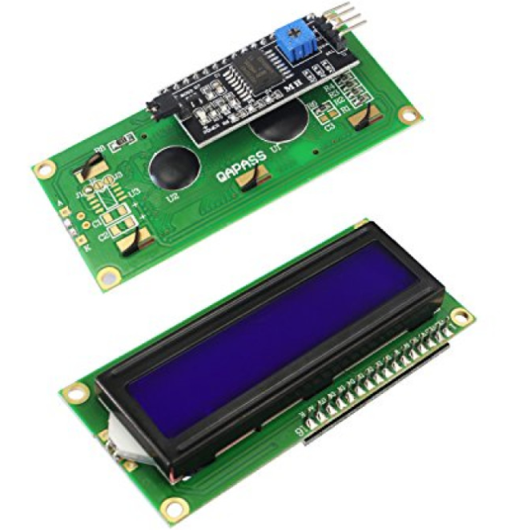

**Fig 4.9**

This is LCD 1602 Parallel LCD Display that provides a simple and cost-effective solution for adding a 16×2 White on Liquid Crystal Display into your project. The display is 16 character by 2 line display has a very clear and high contrast white text upon a blue background/backlight.

**Feature:**

* Green backlight.
* 4-bit or 8-bit MPU interface enabled.
* 80 X 8-bit display RAM (80 characters max).
* Working Voltage: 5V.
* Standard Type.
* Works with almost any Microcontroller.
* Compact size, lightweight, and easy to interface.

## 

**Fig 4.8**

**Water Pump:**

**CHAPTER**

## This DC 3-6 V Mini Submersible Water Pump is a low cost, small size Submersible Pump Motor which can be operated from a 2.5 ~ 6V power supply. It can take up to 120 liters per hour with a very low current consumption of 220mA. Just connect tube pipe to the motor outlet, submerge it in water, and power it.

## Make sure that the water level is always higher than the motor. The dry run may damage the motor due to heating and it will also produce noise.

## Features :

## DC 3v to 6v submersible pump.

## Micro mini submersible water pump 3v to 6v.

## DC water pump for DIY.

## DC pump for the HOBBY kit.

**18650 Battery:**

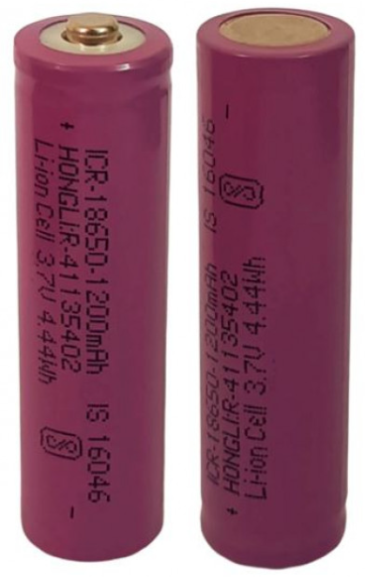

**Fig 4.9**

This is an original 1200mAh 18650 battery. 18650 battery is a Li-ion rechargeable battery with a 1200mAh Battery Capacity. This is not a standard AA or AAA battery but is very useful for applications that require continuous high current or high current in short bursts like in cameras, DVD players, iPod, etc. A 18650 cell can be charged and discharged up to 1000 cycles without much loss in battery capacity. They are safe to use, environment friendly and have long battery life. It comes with high energy density and provides excellent continuous power sources to your device. It should be used with a protection circuit board that guards the battery against over-charge, over-discharge of the pack, and avoid over-current drawn.

**Features:**

* High energy density
* High working voltage for single battery cells.
* Pollution-free
* Long cycle life
* No memory effect
* Capacity, resistance, Voltage, platform time consistency is good.
* Good consistency and low self-discharge.
* Lightweight, small size
* Shape: Cylindrical Battery
* Battery Type: Lithium-Ion Battery
* High performance and capacity
* Flat top to suit many devices fitting.

## Tactile Push Button:

## 

**Fig 4.10**

An electronic switch is an electronic component or device that can switch an electrical circuit, interrupting the current or diverting it from one conductor to another.

## Components Required for Smart Plant Monitoring:

**Project Software Used**

Blynk App( for IoT control and wireless monitoring).

**Project Hardware Used**

* 1. NodeMCU ESP8266
  2. Soil Moisture Sensor
  3. PIR Motion Sensor
  4. Relay Module
  5. BreadBoard
  6. Jumpers
  7. 18650 Battery
  8. Water Pump
  9. Tactile Push Button
  10. DHT11 Sensor
  11. 16×2 LCD Display
  12. USB cable

## 

## CHAPTER 5

## METHEDOLOGY

## Fig 5.1 shows the block diagram of Automatic Plant Watering System with I0T. Farmer monitors and control system in order to improve the efficiency with help of sensor parameters like temperature, humidity, soil moisture.

## 

## Fig 5.1

## 

## Identify requirements:

## Determine the specific features and functionalities you want your system to have. This may include real-time monitoring of plant parameters such as temperature, humidity, soil moisture, light levels, and water levels. Consider the hardware components you'll need to collect data from the plants and the software capabilities required for data visualization and remote control.

## Choose hardware:

## Select the appropriate hardware components to collect data from the plants. This might include sensors for temperature, humidity, soil moisture, light levels, water level sensors, and a microcontroller or development board to interface with the sensors. Make sure the chosen hardware is compatible with the Blynk platform.

## Set up Blynk:

## Create a Blynk account and set up a new project. Configure the project by selecting the appropriate widgets (e.g., gauges, graphs, buttons) to display and control the plant parameters.

**Connect hardware to Blynk:**

Write code to interface the hardware with the Blynk platform. Use the Blynk library or SDK for your chosen microcontroller or development board to establish a connection with Blynk's servers and send sensor data to the appropriate widgets in your Blynk project.

## Sensor data acquisition:

## Program the microcontroller or development board to read data from the plant sensors at regular intervals. This data should include temperature, humidity, soil moisture, light levels, and any other relevant parameters you want to monitor.

## Data visualization and control:

## Use the Blynk app or web interface to visualize the acquired sensor data in real-time. Create custom dashboards or widgets within the Blynk project to display the plant parameters in a user-friendly format. Implement controls such as buttons or sliders to enable remote control of devices like water pumps or lights.

## Notifications and alerts:

## Set up notifications and alerts within the Blynk platform to inform users about critical plant conditions. For example, you can configure Blynk to send a push notification when the soil moisture drops below a certain threshold, indicating the need for watering.

## Testing and optimization:

## Test the system thoroughly to ensure that it works reliably and accurately captures plant data. Make adjustments as necessary, such as fine-tuning sensor readings or optimizing the responsiveness of the control mechanisms.

## Deployment:

## Once the system is fully tested, deploy it in the desired environment. Install the hardware components in the plant monitoring location and ensure a stable internet connection. Monitor the system's performance and address any issues that arise during the deployment phase.

## Program Code

// Blynk IOT Smart Plant Monitoring System

/* Connections

Relay. D3

Btn. D7

Soil. A0

PIR. D5

SDA. D2

SCL. D1

Temp. D4

*/

//Include the library files

#include <LiquidCrystal_I2C.h>

#define BLYNK_PRINT Serial

#include <ESP8266WiFi.h>

#include <BlynkSimpleEsp8266.h>

#include <DHT.h>

//Initialize the LCD display

LiquidCrystal_I2C lcd(0x3F, 16, 2);

char auth[] = " "; //Enter your Blynk Auth token

char ssid[] = " "; //Enter your DWIFI SSI

char pass[] = " "; //Enter your WIFI Password

DHT dht(D4, DHT11);//(DHT sensor pin,sensor type) D4 DHT11 Temperature Sensor

BlynkTimer timer;

## 

//Define component pins

#define soil A0 //A0 Soil Moisture Sensor

#define PIR D5 //D5 PIR Motion Sensor

int PIR_ToggleValue;

## 

void checkPhysicalButton();

int relay1State = LOW;

int pushButton1State = HIGH;

#define RELAY_PIN_1 D3 //D3 Relay

#define PUSH_BUTTON_1 D7 //D7 Button

#define VPIN_BUTTON_1 V12

//Create three variables for pressure

double T, P;

char status;

void setup()

{

Serial.begin(9600);

lcd.begin();

lcd.backlight();

pinMode(PIR, INPUT);

pinMode(RELAY_PIN_1, OUTPUT);

digitalWrite(RELAY_PIN_1, LOW);

pinMode(PUSH_BUTTON_1, INPUT_PULLUP);

digitalWrite(RELAY_PIN_1, relay1State);

Blynk.begin(auth, ssid, pass, "blynk.cloud", 80);

dht.begin();

lcd.setCursor(0, 0);

lcd.print(" Initializing ");

for (int a = 5; a <= 10; a++)

{

lcd.setCursor(a, 1);

lcd.print(".");

delay(500);

}

lcd.clear();

lcd.setCursor(11, 1);

lcd.print("W:OFF");

//Call the function

timer.setInterval(100L, soilMoistureSensor);

timer.setInterval(100L, DHT11sensor);

timer.setInterval(500L, checkPhysicalButton);

}

//Get the DHT11 sensor values

void DHT11sensor()

{

## float h = dht.readHumidity();

float t = dht.readTemperature();

if (isnan(h) || isnan(t)) {

Serial.println("Failed to read from DHT sensor!");

return;

}

Blynk.virtualWrite(V0, t);

Blynk.virtualWrite(V1, h);

lcd.setCursor(0, 0);

lcd.print("T:");

lcd.print(t);

lcd.setCursor(8, 0);

lcd.print("H:");

lcd.print(h);

}

//Get the soil moisture values

void soilMoistureSensor() {

int value = analogRead(soil);

value = map(value, 0, 1024, 0, 100);

value = (value - 100) * -1;

Blynk.virtualWrite(V3, value);

lcd.setCursor(0, 1);

lcd.print("S:");

lcd.print(value);

lcd.print(" ");

}

## //Get the PIR sensor values

void PIRsensor()

{

bool value = digitalRead(PIR);

if (value) {

Blynk.logEvent("pirmotion","WARNNG! Motion Detected!"); //Enter your Event Name

WidgetLED LED(V5);

LED.on();

}

else

{

WidgetLED LED(V5);

LED.off();

}

}

## 

BLYNK_WRITE(V6)

{

PIR_ToggleValue = param.asInt();

}

BLYNK_CONNECTED() {

// Request the latest state from the server

Blynk.syncVirtual(VPIN_BUTTON_1);

}

BLYNK_WRITE(VPIN_BUTTON_1)

{

relay1State = param.asInt();

digitalWrite(RELAY_PIN_1, relay1State);

}

void checkPhysicalButton()

{

if (digitalRead(PUSH_BUTTON_1) == LOW)

{

// pushButton1State is used to avoid sequential toggles

if (pushButton1State != LOW)

{

// Toggle Relay state

relay1State = !relay1State;

digitalWrite(RELAY_PIN_1, relay1State);

// Update Button Widget

## Blynk.virtualWrite(VPIN_BUTTON_1, relay1State);

## }

pushButton1State = LOW;

}

else

{

pushButton1State = HIGH;

}

}

void loop()

{

if (PIR_ToggleValue == 1)

{

lcd.setCursor(5, 1);

lcd.print("M:ON ");

PIRsensor();

}

else

{

lcd.setCursor(5, 1);

lcd.print("M:OFF");

WidgetLED LED(V5);

LED.off();

}

if (relay1State == HIGH)

{

lcd.setCursor(11, 1);

lcd.print("W:ON ");

}

## else if (relay1State == LOW)

{

lcd.setCursor(11, 1);

lcd.print("W:OFF");

}

Blynk.run();//Run the Blynk library

timer.run();//Run the Blynk time

}

**Advantages:**

## Real-time monitoring: The system allows you to monitor your plants in real time, providing up-to-date information about their health and environmental conditions. This enables you to promptly address any issues and optimize the care for your plants.

## Remote access and control: With the Blynk IoT platform, you can access and control your plant monitoring system from anywhere using a smartphone or computer. This means you can check on your plants and make adjustments to their care even when you're away from home.

## Customizable alerts and notifications: The system can be configured to send you alerts and notifications based on predefined conditions. For example, you can receive notifications when the soil moisture level is too low or when the temperature reaches a certain threshold. This helps you stay informed about your plants' needs and take timely actions.

## Data analytics and insights: The Blynk IoT platform provides data analytics and insights about your plants' growth patterns, environmental conditions, and historical trends. This information can help you make informed decisions about plant care, optimize resource allocation, and identify patterns or issues that may affect their well-being.

## Automation and scheduling: The system supports automation and scheduling features, allowing you to automate certain tasks and create customized care routines for your plants. You can set watering schedules, adjust lighting conditions, and control other environmental factors based on your plants' specific requirements.

## Integration with other smart devices: The Blynk IoT ecosystem is designed to integrate with a wide range of smart devices and sensors, enabling you to expand your plant monitoring system and enhance its capabilities. For example, you can connect moisture sensors, light sensors, or smart irrigation systems to the Blynk platform for a comprehensive plant care solution.

## User-friendly interface: The Blynk app offers a user-friendly interface that simplifies the setup, configuration, and monitoring of your smart plant monitoring system. It provides intuitive controls, visualizations, and an easy-to-navigate dashboard, making it accessible to both beginners and experienced users.

**Disadvantage:**

**Connectivity issues:** IoT devices rely on stable internet connections for data transmission. If the device is located in an area with poor network coverage or experiences frequent connection drops, it can affect the reliability and real-time monitoring capabilities of the system.

**Power supply:** IoT devices require a power source, and if the device doesn't have a reliable and continuous power supply, it can lead to interruptions in monitoring or complete system failure.

**Compatibility:** IoT systems may have compatibility limitations with certain types of plants, sensors, or environments. It's important to ensure that the system is suitable for the specific requirements of the plants being monitored.

**Sensor accuracy:** The accuracy of sensors used in plant monitoring systems can vary. In some cases, the measurements may not be as precise or consistent as desired, which can affect the reliability of the data being collected.

**Data security:** IoT devices are susceptible to security breaches, and plant monitoring systems are no exception. Weak security measures can expose the system to unauthorized access or data breaches, potentially compromising the privacy and integrity of the data.

**Scalability:** Depending on the specific system design, scalability can be a limitation. Some IoT systems may struggle to handle a large number of devices or plants simultaneously, affecting their overall performance and monitoring capabilities.

## CHAPTER 6

## CONCLUSION

The implementation of Smart Garden system using the Internet of Things has been verified to satisfactorily work by connecting different parameters of the soil to the cloud and was successfully controlled remotely through a mobile application. The system designed not only monitors the sensor data, like moisture, humidity, temperature and ultrasonic but also actuates other parameters according to the requirement, for example, if the water level in tank is reduced to a minimum value then the motor switch is turned on automatically to the water level of the tank reaches the maximum value. The initial cost and the installation of this system are cheap and hence it can be implemented anywhere. With the development of sensor technology, the system can be elevated to the next level which helps the users to utilize their investment in an economic manner. If soil nutrient sensors can be installed, then the system can be modified to supply fertilizers to the garden precisely. This system saves manpower and efficiently utilizes the water resources available ultimately leading to more profit. The feedback provided by the system will improve the implementation of the gardening process A system to monitor temperature, humidity, moisture level in the soil was designed and the project provides an opportunity to study the existing systems, along with their features and drawbacks. Agriculture is one of the most water-consuming activities. The proposed system can be used to switch the motor (on/off) depending on favourable condition of plants i.e sensor values, thereby automating the process of irrigation. Which is one of the most time efficient activities in farming, which helps to prevent over irrigation or under irrigation of soil thereby avoiding crop damage. The farm owner can monitor the process online through a android App. Though this project can be concluded that there can be considerable development in farming with the use of IOT and automation.

**Feature Scope:**

The performance of the system can be further improved in terms of the operating speed, memory capacity, and instruction cycle period of the microcontroller by using other high end controllers. The number of channels can be increased to interface more number of sensors which is possible by using advanced versions of controllers.

The system can be modified with the use of a data logger and a graphical LCD panel showing the measured sensor data over a period of time.A speaking voice alarm could be used.The device can be made to perform better by providing the power supply with the help of renewable source. Time bound administration of fertilizers, insecticides and pesticides can be introduced.

**Limitation:**

* Automated irrigation system uses only two parameters of soil like soil moisture and temperature other parameters humidity, light, air moisture, soil ph value not taken for decision making.
* Excessive seepage and leakage of water forms marshes and ponds all along the channels. The marshes and the ponds in course of time become the colonies of the mosquito, which gives rise to a disease like malaria.

**REFERENCES:**

## 1] J. G. Jaguey, "Smartphone irrigation sensor," Sensors Journal, vol. 15, 2015.

## 2] D. Chaparro, MerceVall-llossera, M. Piles, A. Camps, C. R¨udiger and R. Riera-Tatch, "Predicting the Extent of Wildfires Using Remotely Sensed Soil Moisture and Temperature Trends," IEEE journal of selected topics in applied earth observations and remote sensing, vol. 9, 2016.

## 3] G. nisha and J. megala, "wireless sensor network based automated irrigation and crop field monitoring system," in sixth international conference on advanced computing, 2014.

## 

## 4] A. Anil, "Project HARITHA - An Automated Irrigation System for Home Gardens,"

## 2022.

## 

## 5] J. gutiérrez, "Automated irrigation system using a wireless sensor network and gprs," ieee transactions on instrumentation and measurement, vol. 63, 2014.

## [6] J. Ruan, P. Liao and C. Dong, "The Design and Research on Intelligent Fertigation System," in 7th International Conference on Intelligent Human-Machine Systems and Cybernetics, 2015.

## 

## [7] "acurite," 4 April 2018. [Online]. Available: [https://www.acurite.com/blog/soil-moisture guide-for-plants-and-vegetables.html](https://www.acurite.com/blog/soil-moisture%20guide-for-plants-and-vegetables.html).

## [8] [Online]. Available: https://nrcca.cals.cornell.edu/soil/CA2/CA02 12.1-3.php.

## 

## [9] G. S. V. K. R. Yakkundimath, "Plant Disease Detection using IoT," 2018.

## 10]<http://www.ewaterautosys.com/water-automation-system.html>

## [11]<http://www.wplawinc.com/agricultural-irrigation-blog/the-most-common-problems-with-farm-irrigationsystems>

## [12] [https://www.pwc.com/us/en/increasing-it- effectiveness/assets/future-of-the-internet-of-things.pdf](https://www.pwc.com/us/en/increasing-it-%20effectiveness/assets/future-of-the-internet-of-things.pdf)

## [13] IOT based Smart Irrigation System SrishtiRawal

## Department of Computer Science, VIT University rawal-2017-ijca-913001.pdf

## 

## [14]Thingspeak : https:// thingspeak.com